## **Project Documentation: InsightStream**

**Project Details**

**\* Project Title**: InsightStream

**\* Team ID**: NM2025TMID47885

**\* Team Leader**: S. Gowtham (mr.gowtham1111@gmail.com)

**\* Team Members**:

* M. Gnanagiri (gnnagiri@gmail.com)

* C. Giridharan (giritharan9842@gmail.com)

* R. Hariharashudhan (hariharashudhanrs29@gmail.com)

**Introduction**

InsightStream is a web application designed to provide curated, real-time news and insights to users. The platform focuses on an intuitive user interface, allowing both casual news readers and information professionals to easily navigate and explore a wide range of news categories from various global sources.

**Key Features**

* API-Sourced News: The application provides a comprehensive library of global news from various categories, ensuring broad coverage of current events.

* Visual News Exploration: Users can discover breaking stories through curated image galleries that provide a visual overview of different news categories.

* Intuitive Design: InsightStream features a clean and modern interface designed for optimal user experience and clear information presentation.

* Advanced Search: A powerful search feature allows users to find specific news articles on topics of interest, delivering tailored content.

**Architecture**

The application is built using a modern, efficient architecture.

* **Frontend**: The user interface is developed with React.js, utilizing Bootstrap and Material UI to achieve a responsive and contemporary design. It handles fetching and displaying news articles and other user interfaces.

* **Backend**: The server-side logic is managed by Node.js and Express.js. The backend is responsible for user authentication, managing API endpoints for fetching news, and processing other user-specific data.

* Database: A database is not currently used for this application.

**Setup and Installation**

To run the InsightStream application locally, follow these steps.

**Prerequisites**

You must have the following tools installed on your system:

* Node.js: The JavaScript runtime environment.

* Git: A version control system to clone the repository.

* Visual Studio Code: The recommended code editor.

* React.js: The frontend framework, which is managed via npm once the project is cloned.

Installation Steps

**\* Get the Code**:

* For a new project, use git clone <repository_url>.

* For an existing project, use git pull to get the latest updates.

* Install Dependencies: Navigate to the project directory in your terminal and run npm install. This command reads the package.json file and installs all required libraries.

* Run the Application: Use the command npm start to run the app on your local machine. The application will be accessible in your web browser, typically at <http://localhost:3000>.

**Folder Structure:**

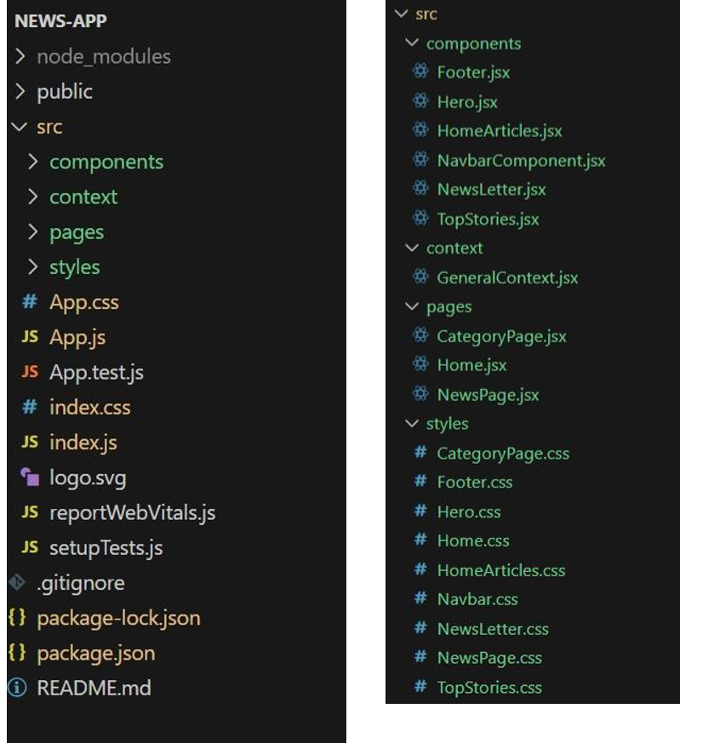

**API Documentation:** NewsAPI 📰

InsightStream uses the NewsAPI.org to fetch news headlines and popular stories.

**Top Headlines**

To get top headlines, the app uses the https://newsapi.org/v2/top-headlines endpoint with the following parameters:

* country: The country code (e.g., us for the United States).

* category: The news category (e.g., business).

* apiKey: Your unique API key.

Example: https://newsapi.org/v2/top-headlines?country=us&category=business&apiKey=YOUR_API_KEY

**ScreenShots** (or) Demo:

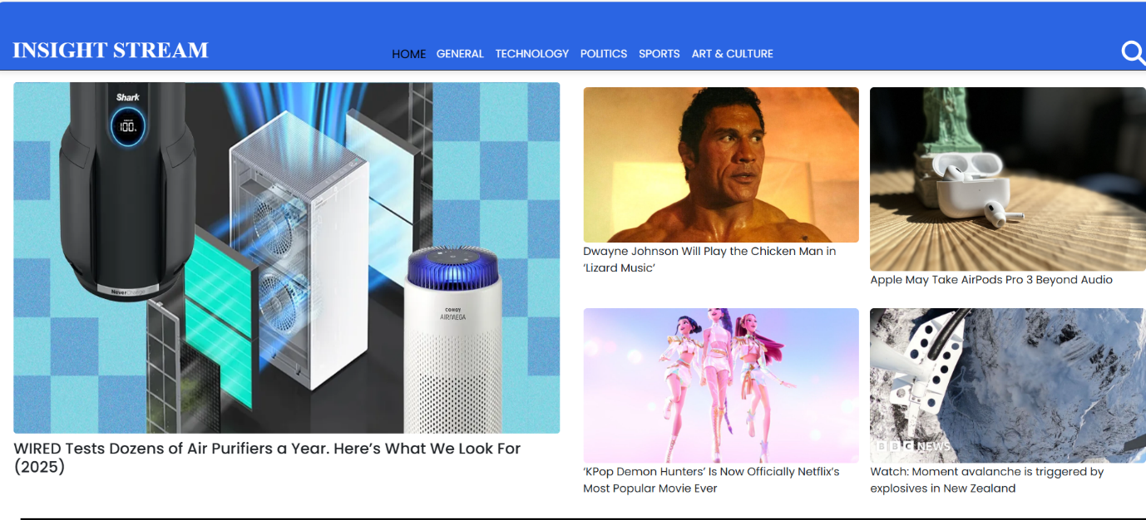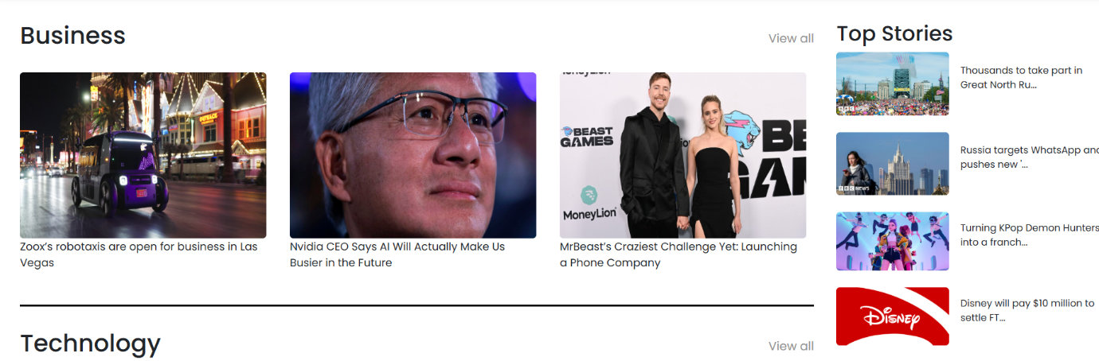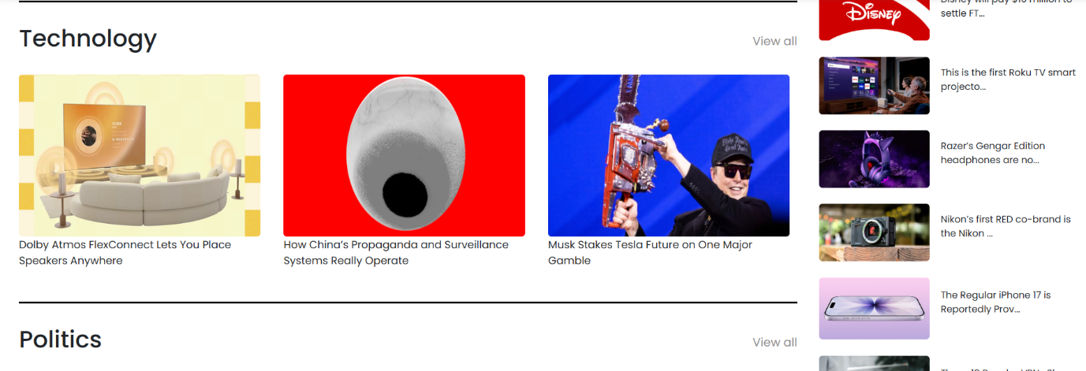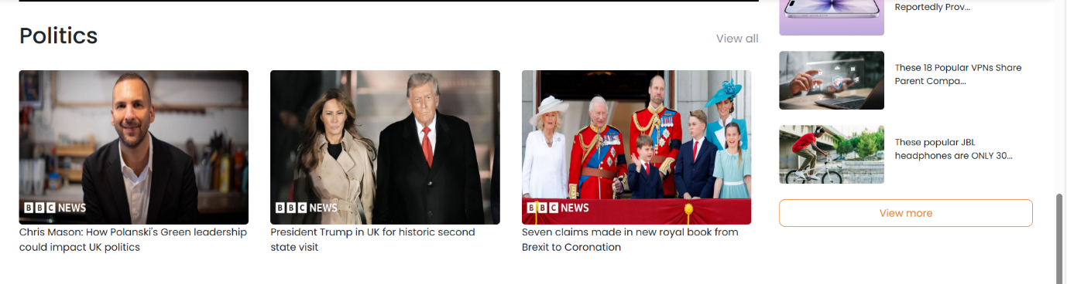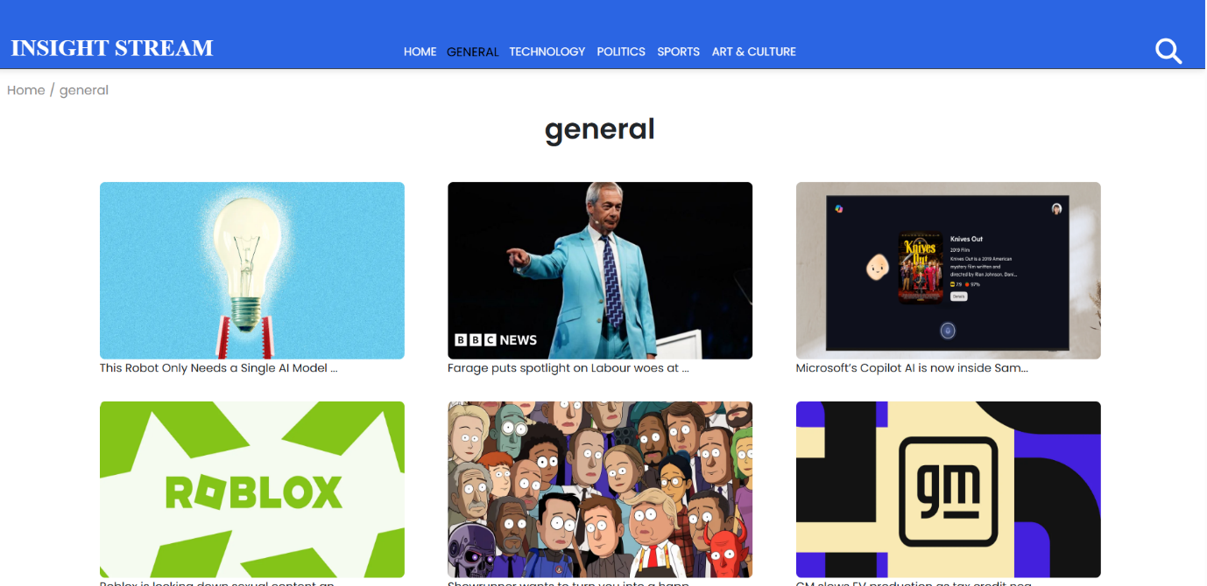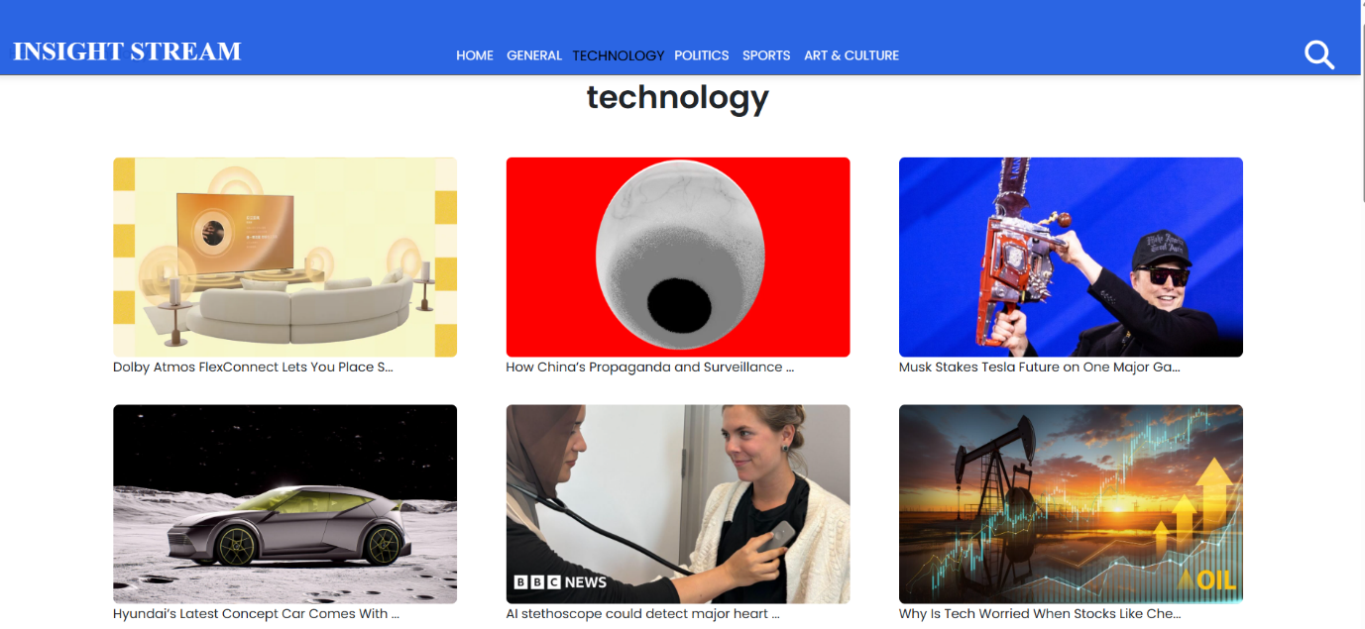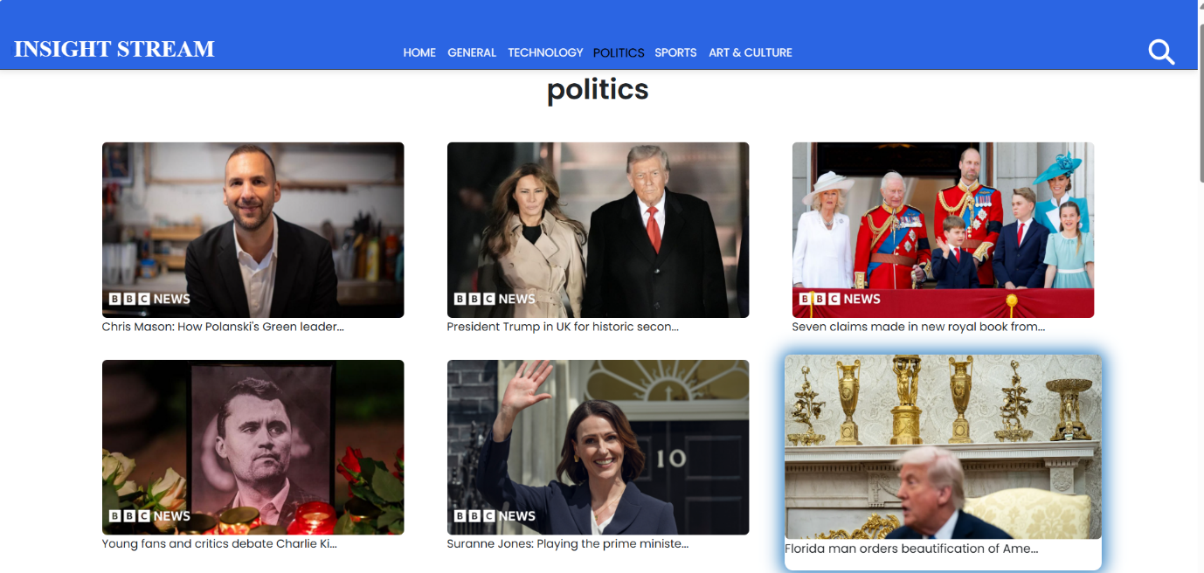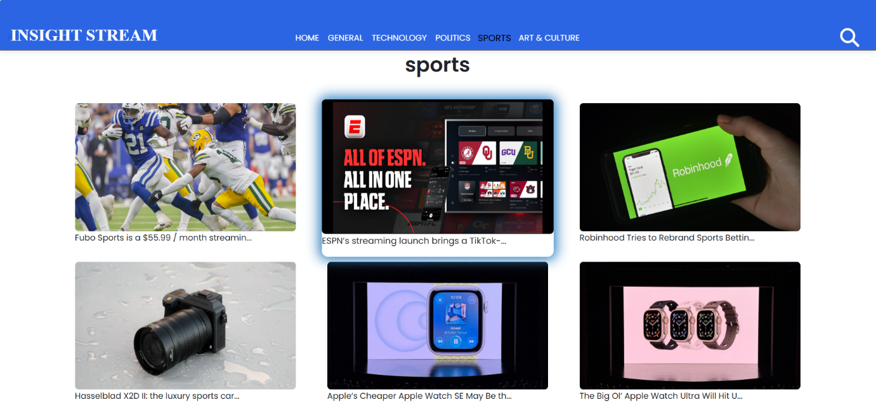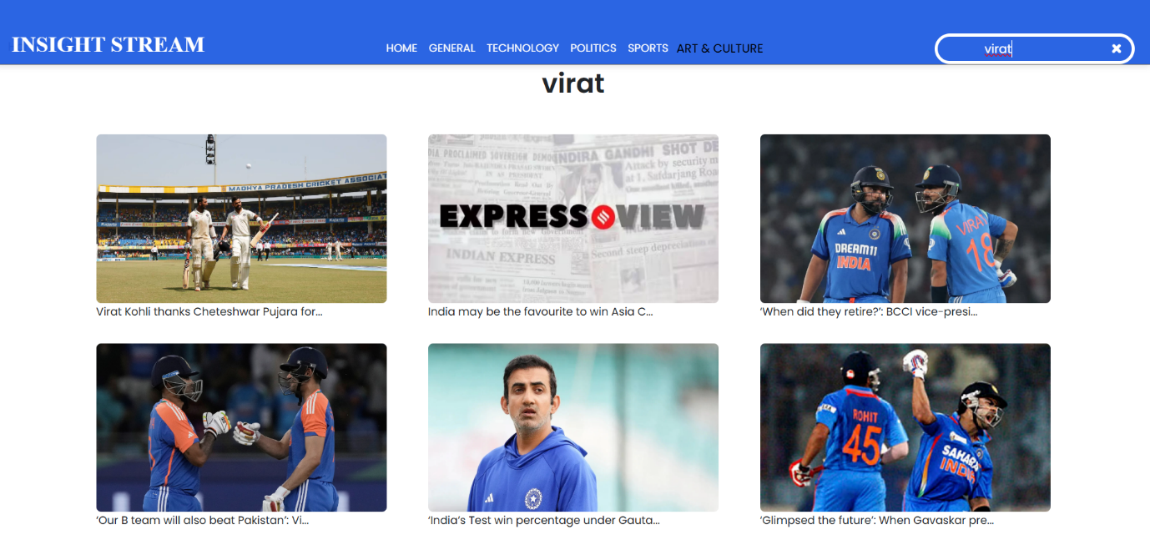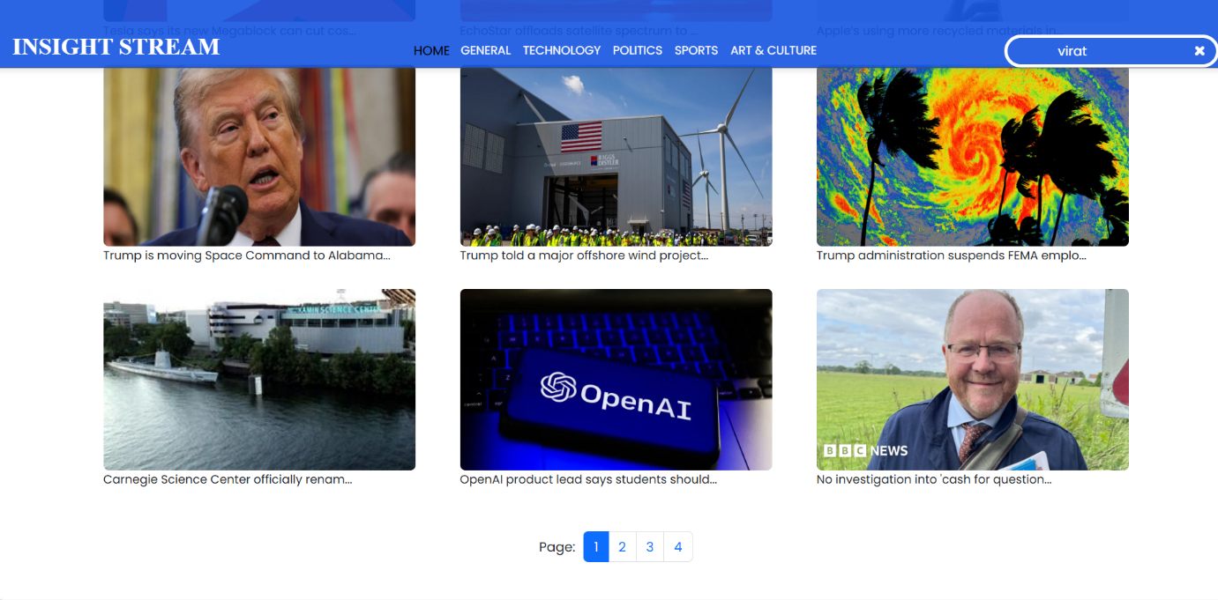

Popular Stories

For popular stories, the app uses the https://newsapi.org/v2/everything endpoint with these parameters:

* q: The search keyword (e.g., business).

* sortBy: Set to popularity.

* apiKey: Your unique API key.

Example: https://newsapi.org/v2/everything?q=business&sortBy=popularity&apiKey=YOUR_API_KEY

The API response is a JSON object containing an array of articles, each with details like the title, description, and URL.

## Known Issues

* Occasional API rate limits for third-party news sources
* Summarization quality may vary based on article length and complexity
* Limited offline access in the current version

**Future Enhancements**

- Mobile app version for iOS and Android  
- Multilingual support for global users  
- Advanced sentiment analysis for news categorization  
- Voice-assisted news browsing  
- Integration with more fact-checking services

This section outlines professional, actionable plans for enhancing the web application.

* User Authentication & Personalization: Implement a robust user authentication system to enable user accounts, providing a foundation for a personalized content feed based on user behavior.

* Dynamic Search & Filtering: Upgrade the search functionality to provide a real-time experience with advanced filters (e.g., by category, source, date).

* Subscription Plans: Introduce a tiered subscription model to monetize the application and offer premium features like unlimited access and an ad-free experience.

* Multiple User Themes: Allow users to switch between light and dark themes to improve usability and reduce eye strain.